Write an assembly language program to perform division of 8-bit data.

CODE:

.model small

.stack 100h

.data

dividend db 64h

divisor db 0Ah

quotient db ?

remainder db ?

msg1 db 'Quotient: $'

msg2 db 0Dh, 0Ah, 'Remainder: $'

.code

main proc

mov ax, @data

mov ds, ax

mov al, dividend

mov bl, divisor

xor ah, ah

div bl

mov quotient, al

mov remainder, ah

mov ah, 09h

lea dx, msg1

int 21h

mov al, quotient

call display_value

mov ah, 09h

lea dx, msg2

int 21h

mov al, remainder

call display_value

mov ah, 4ch

int 21h

main endp

display_value proc

add al, 30h

mov ah, 02h

mov dl, al

int 21h

ret

display_value endp

end main

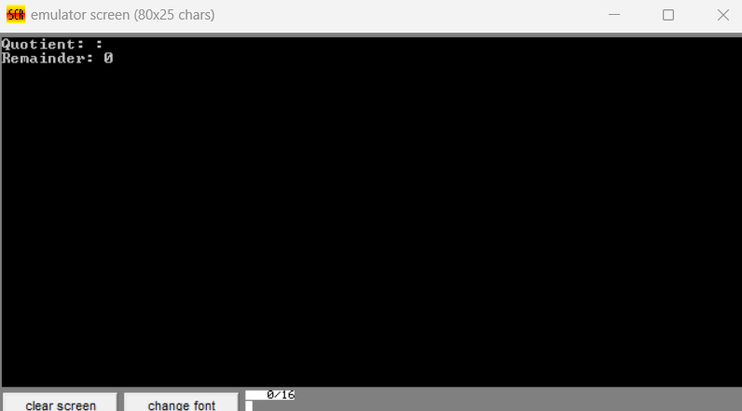

Write a program in assembly language to perform division of 16-bit data.

CODE:

.model small

.stack 100h

.data

dividend dw 1234h

divisor dw 000Ah

quotient dw ?

remainder dw ?

msg1 db 'Quotient: $'

msg2 db 0Dh, 0Ah, 'Remainder: $'

.code

main proc

mov ax, @data

mov ds, ax

mov ax, dividend

xor dx, dx

mov bx, divisor

div bx

mov quotient, ax

mov remainder, dx

mov ah, 09h

lea dx, msg1

int 21h

mov ax, quotient

call display_value16

mov ah, 09h

lea dx, msg2

int 21h

mov ax, remainder

call display_value16

mov ah, 4ch

int 21h

main endp

display_value16 proc

push ax

mov cx, 0

cmp ax, 0

je display_zero

convert_loop:

xor dx, dx

mov bx, 10

div bx

push dx

inc cx

test ax, ax

jnz convert_loop

display_digits:

pop dx

add dl, 30h

mov ah, 02h

int 21h

loop display_digits

jmp done_display

display_zero:

mov dl, '0'

mov ah, 02h

int 21h

done_display:

pop ax

ret

display_value16 endp

end main

